# Technical consultant test case part 2

Follow the instructions below for the second part of the test. There will be additional files provided to you. You may use any resources at your disposal to solve the problem. This technical test has a **2 hour soft time limit.**

Instructions:

Part 1.

1. Setup a new git repository
2. Use Flask to set up a new webserver
3. Use a package from PIP to randomly request a Chuck Norris jokes from the following endpoint: (<http://api.icndb.com/jokes/random/>)
4. When the Flask server starts, make sure you call 10 Chuck Norris jokes
5. Create a Flask endpoint to return the 10 jokes ([http://localhost:5000/getJokes](http://localhost/getJokes))

Part 2. Write a python script to

1. Load the sales data ‘data.xlsx’
2. Calculate the sales and transactions per 15min time bucket
3. Write the results to a csv file

Example format

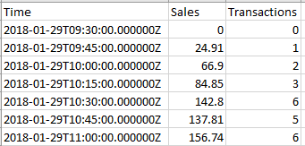

Deliverables:

Please send us the **location of a git repository** containing this application upon completion.

Please proceed to part 3 of the test.